
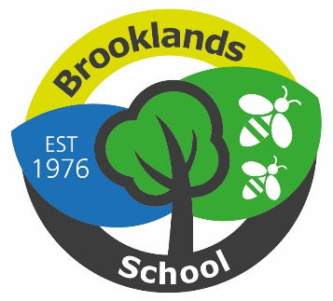

Please find below the term dates for the School Year 2026 - 27.

Staff training days marked with * are set by the Local Authority, the others have been set by school.

Pupils are not expected in school on Training Days.

Term Dates 2026 - 2027

Holiday School Closes School Re-opens on
Autumn Fri 17 July 2026 Tue 8 September 2026
Half-term Thu 22 October 2026 Mon 2 November 2026
Christmas Fri 18 December 2026 Tue 5 January 2027*
Half-term Fri 5 February 2027 Mon 15 Feb 2027
Easter Fri 19 March 2027 Tue 6 April 2027
May Day Fri 30 April 2027 Tues 4 May 2027
Half-term Fri 28 May 2027 Mon 7 June 2027
Summer Fri 23 July 2027* TBC

Pupils not in school:
- Monday 7 September 2026 - Staff training day
- *Friday 23 October 2026 – Staff training day
- *Monday 4 January 2027 - Staff training day
- Monday 5 April 2027 – Staff training day
- Monday 3 May 2027 – May Day
- *Monday 26 July 2027 - Staff training day
*Training Days set by NYC

Burnside Avenue, Skipton, North Yorkshire, BD23 2DB
Prepared, Respectful, Safe
Headteacher: Darren Barham

Telephone: 01756 794028
E-mail: info@brooklands.n-yorks.sch.uk
Web: Brooklands.n-yorks.sch.uk

Brooklands School

